Executive Briefing:

Garage & Shop Floor

Coating Options



An Evaluation of Current Products,

Technologies & Methods

Rev A

©Copyright 2007, all rights reserved,
Atherton-Lake Publishing Group, Inc., Blackhawk, California

Table of Contents

Section 1 An Introduction
- What is a floor coating?
- The objectives of this report
- The problem definition

Section 2 The Nature of Concrete
- Composition
- Porosity
- Chemistry
- Strength

Section 3 Surface Preparation
- Chemical etching
- Sandblasting
- Mechanical grinding

Section 4 Sealers & Waxes
- The Chemistry
- The Coating
- The basic weaknesses

Section 5 Acid Staining
- The new technologies
- The Process
- Colors & Textures

Section 6 Basic Floor Enamel
- The Chemistry
- The Coating
- The basic weaknesses

Section 7 Epoxy Paints
- The Chemistry
- The Myths
- The characteristics & benefits
- Where it works and why

Section 8 Polyurethane Paints
- The Chemistry
- Features & Benefits

Section 9 Polyurethane/Epoxy Hybrid Coating Systems
- The best of both worlds
- The multi-step process
- Why they work

Section 10 Broadcast Aggregates
- The new technologies
- Materials & compositions
- The best of the best

Section 11 Floor Tile
- The new technologies
- Materials & compositions
- Sizes & colors
- Adhesives
- Joint welding

Section 12 Snap-together Tiles
- The systems
- Advantages & disadvantages

Section 13 Roll-Out Sheets
- The products
- Advantages & disadvantages
- Emergency lighting

Appendix Sources & Links

Section 1—Introduction

What is a concrete floor coating?



The predominance of industrial, manufacturing, workshop, garage and hangar floors are of concrete slab construction. While concrete is an ideal construction material it is not without drawbacks.

While many concrete floors go untreated by their users with generally acceptable performance, there is a growing desire to coat these surfaces to avoid some of the more common and undesirable characteristics such as:
- Dust generation
- Porosity allowing staining by chemicals, oils and greases
- Moisture migration from below
- Blooming—the white powder that develops on newly cured concrete surfaces
- Esthetics—avoiding the bland gray concrete appearance

Section 2—The Nature of Concrete

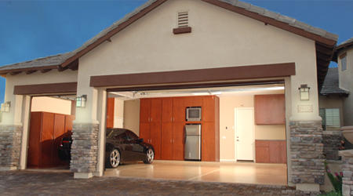

The Material:
Commercial concrete is a composite comprised of calcium carbonate-based cement matrix reinforced with an aggregate such as sand, gravel, reinforcing steel grid, mesh or bar.

Section 3—Surface Preparation

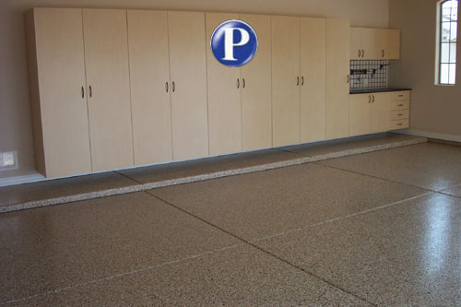

Now, imagine if you had some way of communicating with your loved ones that was outside the normal

Section 4—Sealers & Waxes

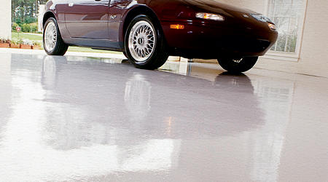

Now, imagine if you had some way of communicating with your loved ones that was outside the normal

Section 5—Acid Staining

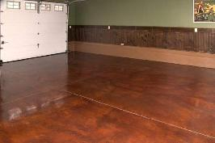

Now, imagine if you had some way of communicating with your loved ones that was outside the normal

Section 6—Basic Floor Enamel

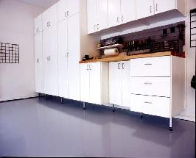

Now, imagine if you had some way of communicating with your loved ones that was outside the normal

Section 7—The Epoxy Paints

Now, imagine if you had some way of communicating with your loved ones that was outside the normal

Section 8—Polyurethane Paints

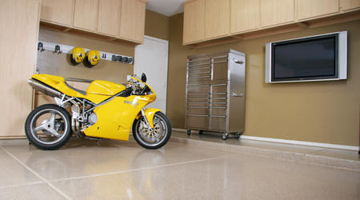

Now, imagine if you had some way of communicating with your loved ones that was outside the normal

Section 9—Epoxy/Polyurethane Hybrid Systems

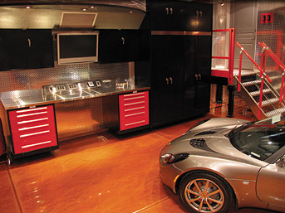

Now, imagine if you had some way of communicating with your loved ones that was outside the normal

Section 10—Broadcast Aggregates Added to

Epoxy/Polyurethane Hybrid Systems

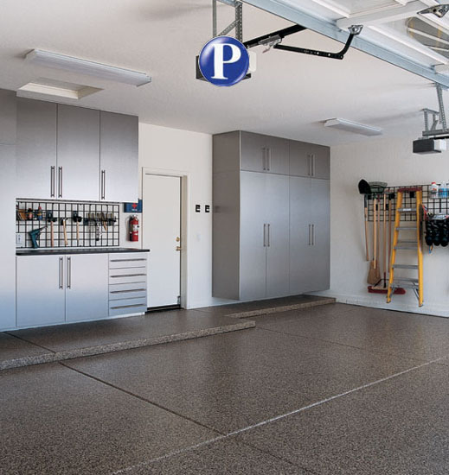

Now, imagine if you had some way of communicating with your loved ones that was outside the normal

Section 11—Floor Tiles

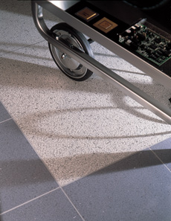

As we have seen, wet-applied coatings, regardless of their technological sophistication, will require significant preparation of the concrete substrate to achieve maximum life and appearance.

In the next sections, we will explore the application of pre-fabricated surfaces in the form of tiles and sheets of various materials.

There are several benefits to this methodology when compared to wet-applied coatings.

Section 12—Snap-Together Floor Tiles—RaceDeck®

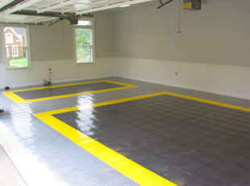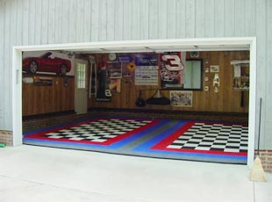

Introduction:
RaceDeck® is a novel approach to a professional looking modular floor covering. Manufactured by Snap-Lock Industries of Salt Lake City, Utah, this is comprised of 12” square tiles of various patterns and colors that simply snap together.

The RaceDeck product line is marketed as the industry leader with more modular garage floors sold and installed than all other competitors combined. The parent company, Snap-Lock, has over 30 years experience in the floor coating industry.

Key Benefits:
- A “multi-patented” floor system that has been engineered to withstand the toughest mechanical environments.
- Material can be disassembled and moved to another facility.
- Can be installed in a few hours compared to several days.
- Is ready for use immediately upon completion of install.
- Can be installed in a section at a time—facility contents can be moved from one area to another to accommodate the install and moved back immediately on completion.
- Requires no preparation of underlying substrate surface.
- Requires no adhesives.
- There are no fumes, vapors, dusts, and no acid etchants required.
- Designed to keep you and your machines up and away from dirt, mud, debris, and flowing liquids giving you a professional clean work area.
- Installation is a “SNAP”! No tools required – simply “snap” together to form any size custom floor.
- Engineered to be used on any flat surface – both indoors and outdoors.
- Easy to clean. Just hose off or mop it.
- More color and style options than all other modular flooring manufacturers combined.
- Features a 15-year limited warranty.
- Easily repaired if damaged—simply replace the damaged tiles by snapping out the damaged tiles and snapping in the fresh ones.

Material:
- Molded from a high-impact copolymer
- UV stable and stain resistant.

Capacities:
- Engineered to handle extreme vehicle rolling load capacities
- Resistant to oil, grease, petroleum products, antifreeze and most household chemicals.

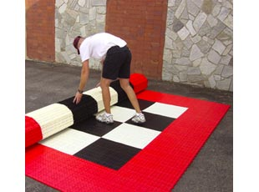

EASY INSTALLATION (NO TOOLS NEEDED)
 | 
Start by laying your first panel on any corner. The loops should be pointed in the direction you want to add panels. | The panels have 2 sides with female loops, and 2 sides with male pegs.

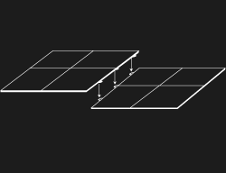 | 
Place the next panel so that the pegs line up over the loops. | Gently step on each panel. You will hear and feel it snap into place. Repeat these steps until your flooring is complete. That’s all there is to it!
All tiles on any given installation should ALWAYS HAVE THE FEMALE LOOPS GOING IN THE SAME DIRECTION. (illustration 1)
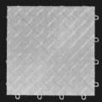
Illustration 1

CONTACT US  Toll Free:  1-800-457-0174  Local or International:  1-801-746-0143  Fax:  1-801-746-0180 | Snap Lock Industries  2330 W. California Ave.  Salt Lake City, UT 84104  U.S.A.

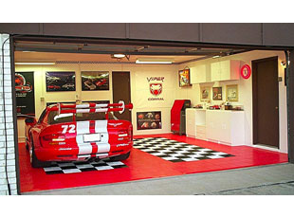

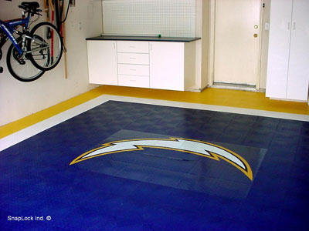

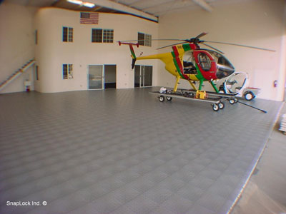

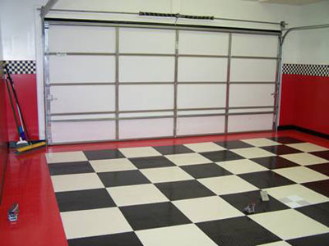



Section 13—Roll-Out Mats

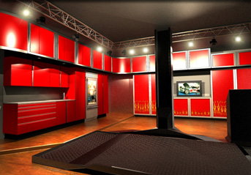

Now, imagine if you had some way of communicating with your loved ones that was outside the normal

Appendix—Sources & Links

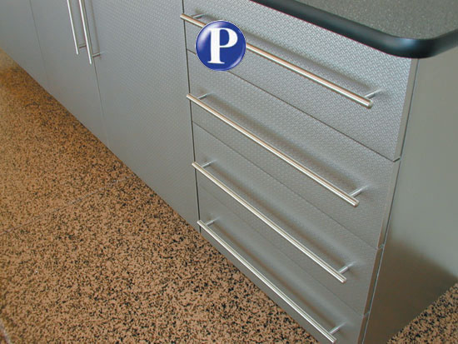

Now, imagine if you had some way of

